Name: ………………………………………. Class: ……………………………………..

​​Y8 RE KNOWLEDGE ORGANISER HOMEWORK SPRING 1

Unit 3 : Introduction to Dharmic Traditions

L1: The Origins of the Dharmic Traditions
L2: The Origins of the Dharmic Traditions
L3: The Origins of the Dharmic Traditions

Unit 4 : Study of Hindu Dharma
L1: Ultimate Reality - Brahman
L2: The Trimurti
L3: Authority and Sacred Texts
L4: Hindu Worship
L5: Festivals
L6: Rituals
L7: Pilgrimage
L8: Ahimsa

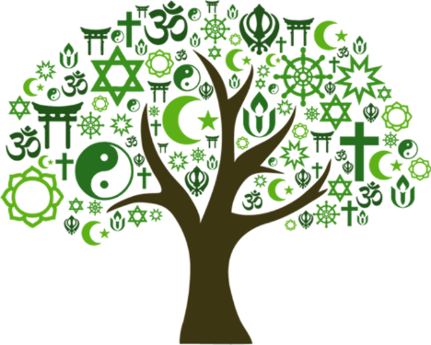

L1: The Origins of the Dharmic Traditions
- What is often translated as ‘duty’ ;includes human behaviour, justice and living in harmony with the world? | Dharma
- What are the three Dharmic faiths commonly found on the Indian sub continent? | Hindu Dharma, Buddhism and Sikhi
- A spiritual force or truth behind everything in the universe is known as… | Ultimate reality
- Which religion teaches people how to end suffering by following the Buddha’s teachings? | Buddhism
- Which religion teaches people how to live well by following their duty (dharma), seeking truth and aiming for spiritual freedom (moksha)? | Hindu Dharma
L2: The Origins of the Dharmic Faiths
- The cycle of birth, life, death and rebirth is known as… | Samsara
- In Hindu Dharma, the idea that actions and choices have consequences is known as… | Karma
- What is the Hindu idea of the soul, the true self? | Atman
- Freedom from the cycle of birth, death and rebirth where the soul (atman) becomes one with ultimate reality is known as… | Moksha
- What is the idea that time goes round and round in a repeating cycle. | Cyclical
L3: The Origins of the Dharmic Faiths
- What does migration mean? | People moving from one country to another
- Which country gained independence in 1947? | India
- After World War II people migrated from where to the UK? | India, Pakistan, Sri Lanka and East Africa
- In 1972 many Hindus and Sikhs were expelled from which country? | Uganda
- How many Hindus make up the UK population? | 1.7%

L1: Ultimate Reality - Brahman
- What does Brahman mean? | Ultimate reality
- What is moksha? | Freedom from the cycle of samsara
- What story shows how different people can understand the same truth in different ways? | The Story of The Blind Men and the Elephant
- What is the difference between monotheism and polytheism? | Monotheism is the belief in one God, Polytheism is the belief in many
- The belief that God is in everything and everything is part of God is known as… | Pantheism
L2: The Trimurti
- Who is Brahma, Vishnu and Shiva? | The creator, the preserver and destroyer
- Name one key characteristic of Shiva | Blue face and throat (or whole body)
- Name a key characteristic of Vishnu | Often crouched on a lotus flower which symbolises beauty and freedom
- Hindus who worship Shiva as their main deity are part of a tradition called… | Shaiviam
- What is a deity may take on different forms called? | Avatars
L3: Authority and Sacred Texts
- How old are the oldest Hindu texts? | 3000 years old
- What does Upanishads mean? | to sit up close
- What does Sanatana Dharma mean? | Universal (eternal) duty
- What does Varnashrama Dharma mean? | Individual duty
- It is better to do your own ____, even imperfectly, than to do someone else’s ____ perfectly." - Bhagavad Gita | Duty
L4: Hindu Worship
- What is Hindus place of worship? | Mandir
- Name five things used in a Puja Ceremony? | Bell, Arti/Diya lamp, Incense, Aum, Tilak powder, Offerings, water and spoon
- An image or statue representing the deity is called… | Murtis
- A typical visit to the temple might include… | - Removing shoes as a sign of respect  - Ringing a bell to announce presence  - Offering flowers, fruit, or money
- What is Prasad? | A sacred food often distributed after being offered to a deity
L5: Festivals
- What is the Ramayana? | A long epic poem about heroic deeds
- Dawali is the time of … | Joy and light
- Name three ways Dawali is celebrated in the UK | Flighting Diyas and candles, decorating, fireworks and sparklers, Likshmi Puja, Visiting the Mandir, community events.
- Who did Vishnu reincarnate into? | Rama, a noble price and warrior
- Who did Vishnu fight? | Ravana a ten headed demon
L6: Rituals
- What is Namakarana? | Baby naming ceremony
- What are the three parts of samsara? | Birth, Death and Rebirth
- What are the three things names are based on? | Hindu astrology, names of the deities, sounds and syllables
- What is the aim of funerals? | To guide the soul from this life to the next stage
- How long must a Hindus be cremated after death | one or two days
L7: Pilgrimage
- Define Pilgrimage | A journey to a place that is important in a religion or tradition
- More than 400 million people live on and around which river? | River Ganges
- Define moksha | Ultimate spiritual liberation
- What is the worlds largest Hindu pilgrimage? | Kumbh Mela
- What happens during Kumbh Mela? | Bathing, celebrations, gathering and a community, prayers and ceremonies
L8: Ahimsa
- Define Ahimsa | The principle of Non- Violene
- Who promoted peaceful protests for Indias independence? | Mahatma Gandhi
- Hindus avoid harming which animal? | Cows
- What does the Bhoodan Movement? | Land Gift Movement
- “Thy ________ deepens to a mighty speech” Sarojini Naidu | Silence

